**INPUT**

<html>

<head>

<title>Employee Salary</title>

</head>

<body>

<form method="POST">

<h1>Enter Your Details Below</h1>

Enter Your ID : <input type="text" name="id" placeholder="enter ID"><br><br>

Enter Years Of Experience : <input type="text" placeholder="enter experience" name="exp"><br><br>

Enter Average Salary : <input type="text" placeholder="average salary" name="sal"><br><br>

Employement Status: <select name="status">

<option name="employeed">Employeed</option>

<option name="unemployeed">Unemployeed</option>

</select><br><br>

<input type="submit" name="submit" value="Submit">

</form>

</body>

</html>

<?php

if(isset($_POST['submit']))

{

$ddl=$_POST['status'];

if($ddl=="Employeed")

{

$salary=$_POST['sal'];

$cal=$salary*12;

echo '<label>Your Total Salary Earned Over The Years Is : </label>'.$cal;

}

else

{

echo 'You Are Not Employeed';

}

}

?>

**OUTPUT**





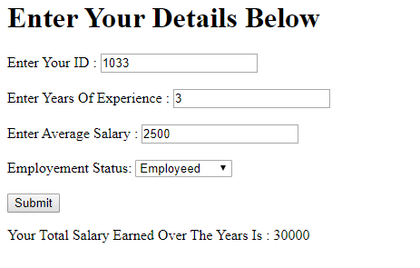

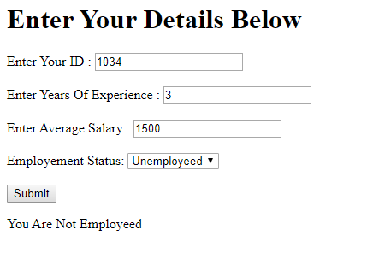

**INPUT**

<html>

<head>

<title>Movie Program</title>

</head>

<body>

<form method="post">

Enter Movie Name:<input type="text" name="M_name">

<select name="choice">

<option value="delete">Delete The Movie</option>

<option value="year">Display Realising date</option>

<option value="desc">Movie Name in descending order</option>

</select><br><br>

<input type="submit" name="submit" value="Submit"><br><br>

</form>

<?php

$movies_name= array('Dark Phoenix' =>2019 , 'The Avengers'=>2012, 'Deadpool'=>2016,'The Wolverine'=>2013,'Spider-Man'=>2002,'Avengers: Endgame'=>2019);

if(isset($_POST["submit"]))

{

$choice=$_POST["choice"];

$Mo_name=$_POST["M_name"];

switch ($choice)

{

case 'delete':

if(array_key_exists($Mo_name,$movies_name))

{

unset($movies_name[$Mo_name]);

echo "Movie" .$Mo_name. " Deleted succesfully ";

foreach ($movies_name as $key => $value)

{

echo $key."<br>";

}

}

else

{

echo $Mo_name." Movie is not Present in the Array ";

}

break;

case 'year':

if(array_key_exists($Mo_name,$movies_name))

{

echo $Mo_name."is released on ".$movies_name[$Mo_name];

}

else

{

echo $Mo_name." Movie is not Present in the Array ";

}

break;

case 'desc':

arsort($movies_name);

foreach ($movies_name as $key => $value)

{

echo $key."<br>";

}

break;

default:

break;

}

}

?></body>

</html>

**OUTPUT**

